INSTRUCTIONS FOR NB 4H TRADING SYSTEM Version 5.0
To put these folders in their proper places please follow these instructions. Make sure you have an MT4 trading platform from the broker of your choice. This system was tested on a live IBFX account With IBFX .01 lot equals one penny and FXSol .01 equals one dime. Though MT4 platforms are nearly the same many brokers have them adjusted for their particular use. .01 with one company may mean a penny per pip and another it could be a dime per pip. Some use 4 digits trading some use 5 digits. It is critical you know the difference so you know what you are trading. None of the EAs have stop loss or take profit settings. This is so ECNs can use them. You will have to input your own SL and TP settings or use the TP EAs.

To get to the folders to place the different parts of this system into correctly follow these steps.
- Click on my computer
- Click on local disk C: or wherever your MT4 platform is located on your computer
- Click on program files.
- Click on the MT4 folder you are using, IBFX will say Interbank FX Trader.
- When you open that folder you will see several folders, you will now put folders or programs inside these folders.
  - Open ‘templates’ folder of MT4. From inside the ‘templates’ copy all the templates and then paste them inside the MT4 templates folder. Close folder and go back.
  - Open the ‘experts’ folder of MT4. Paste the EAs inside the expert’s folder. DO NOT CLOSE THE FOLDER.
  - See the folder called ‘indicators’. Open that MT4 folder and place inside the programs from ‘indicators’ close that folder and go back one folder.
  - You will see a folder called ‘scripts’ open that folder and put inside there the ‘close all’ script from the ‘script’ folder.
  - You now have all the programs installed that you will need for this system. Close all folders and windows and open MT4.
- If your system is like IBFX and uses penny lots you are ready to go. If you want to use the dime EAs or your broker uses .10 lots, you will have to change the EA sections
  - OK with MT4 open, go to the upper left corner and click on navigator. Navigator is the button with the yellow folder and yellow star on it. It will open a box on the left side of your screen. Should look like this. (next page)
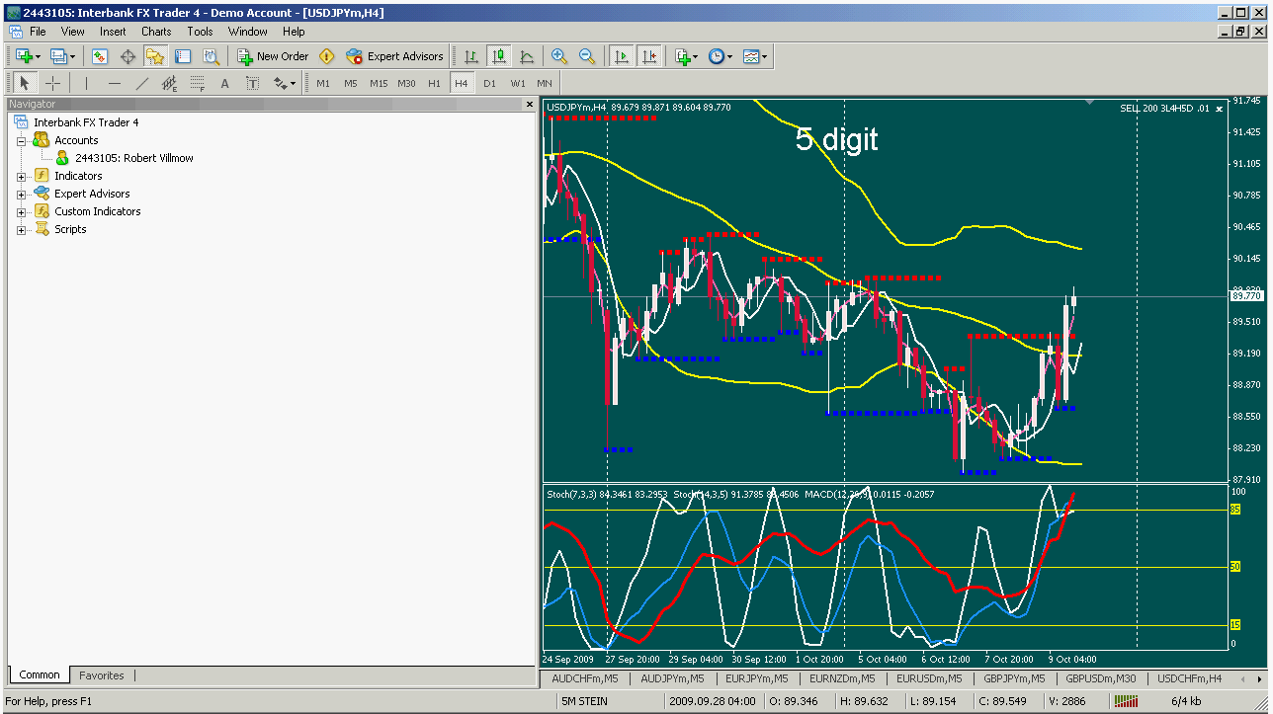

  - Click on Expert advisors and it will look like this.

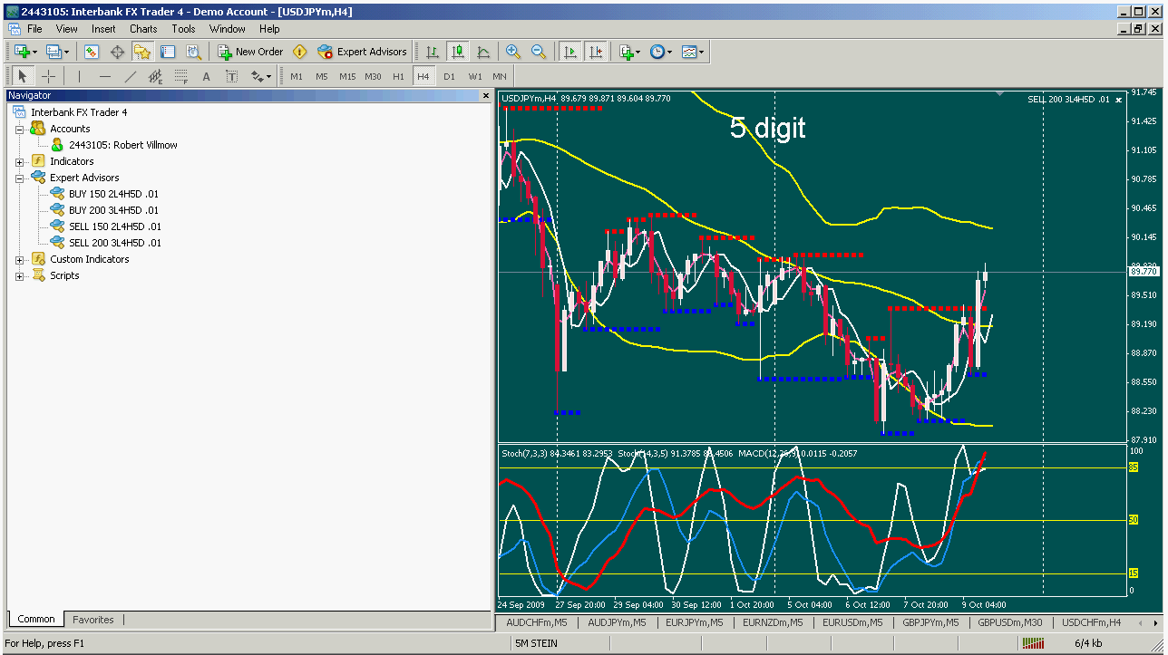
  - Right click on any of the EAs; click Modify and a separate window will appear. You can now make changes in the code. In the top third of the code is where you want to make your changes. Look at this section of the code. (next page)

extern double Lot=0.01;
extern double TakeProfit=0;
extern double StopLoss=0;
extern int MagicNumber=1;
extern string TradeComment="1.0 5x5 buy";
extern bool CriminalIsECN=true;
extern bool UseSafetyFeature=true;

  - If you want to change lot size change the yellow section from .01 to .10. Some brokers do not use .01 lots so the EA will not work with these brokers until you change the .01 to .10.

  - When you are done making your changes go to the upper left and do a ‘save as’ with a new name for the EA if you wish to have an EA with your own settings. THEN this is very important Hit the compile button at the top center of your screen. If you did the changes properly it will give you a message at the bottom that says: ‘0 errors, 0 warnings’ if you did it correctly the new EA is ready to go.
  - Take the EA and drag it onto your screen and save the new template. If you need to change EAs to the same parameters, change the EAs using the same steps mentioned above and when you are done: You are now ready to trade.
- Trading
  - When you see a trade scenario you like, go to the Expert Advisors and choose the buy EA or the sell EA you wish to use. When price hits the 5MA line on the 1H chart the EA will then enter a buy or a sell. After this point happens you can put the template without an EA on and then manage your trade manually or you can leave the template on. Trades are only executed at the MA line. I have tried my best to make sure everything is error free but if you ask my wife you will find out that I am not perfect. Please demo this until you are comfortable with the system.
Happy trading,
Nanningbob
January 1, 2011

